Release Assembly - TopCoder Cockpit Project Dashboard Project Type and Permission Notifications Integration Deployment Guide

Revision History
Author | Revision Number | Date
TCSASSEMBLER | 1.0 | 06/13/2012

Deployment Instructions 3
1. Organization of Submission 3
2. Application Setup 3
2.1 Ant .Properties File 3
2.2 Configurations 3
2.3 Build Scripts Setup 3
3. Database Setup 4
4. Deployment Instructions 4
5. Starting 4
6. Verification 4
7. Resource Contact List 13

Deployment Instructions

Organization of Submission

The submission follows directory structure provided below:

doc
Contains the Deployment Guide Document of this assembly.

direct
Contains sources and static files for Direct web application. This directory replicates the application development distribution structure and includes only updated and new files.
test_files
Contains the SQL files to insert test data

Application Setup

The application is expected to be deployed to the following environment:

JRE 1.5
JBoss 4.2.3.GA
Informix DS 11.5

Ant .Properties File

Configurations

token.properties needs to be updated on VM to use the forum EJB and enable createForum flag

Property Name | Sample
@forumBeanProviderUrl@ | jnp://localhost:1199
@studioForumBeanProviderUrl@ | jnp://localhost:1199
@createForum@ | true

Build Scripts Setup
The ANT build script for Direct application (build.xml) provides the following targets which are to be used:

- switch-and-checkout – checkout or switch to the defined source code branches for all components defined in subprojects.xml
- dist-backend – rebuilt all the components from the source code.
- first_deploy – must be the first task to execute from command line. It will copy all dependencies to your local JBoss folder.
- deploy – should be the main task to execute from command line. It will build and deploy WAR file.
- deploy-static-files – deploys the static files to JBOSS.
- deploy-apache-static – deploys the static files to apache server on VM.

Please refer here for more information:
http://www.topcoder.com/wiki/display/docs/TC+Direct+Setup+Guide

Database Setup
- None

Deployment Instructions

This section provides the instructions in Production environment.

- Merge the code from submission into SVN for Direct application
- Go to the directory project_service_facade, run ‘ant dist_tcs’ to rebuild the component
- Go to the directory contest_service_facade, run ‘ant dist_tcs’ to rebuild the component
- Build and deploy Direct application using ant deploy (or ant first_deploy ) command.
- Copy static files using ant deploy-static-files command or ant deploy-apache-static if use apache as static file server.

Starting

- Build and deploy the Direct application
- Start JBoss server instance hosting Direct application

Verification

Set up test data first, run the following SQL scripts in order against the test server database:
- test_files/project_forum_setup.sql

Use various browsers to open the link http://localhost:8180/direct or https://[vm_ip]/direct/ , login as heffan / password.

Because we need to test the project forum, so we do not use test data to insert project first. We can simply create several new projects in Cockpit to test. In this way, the project forums can be created automatically.

Click the “Launch Contest” button, then go to the launch contest page

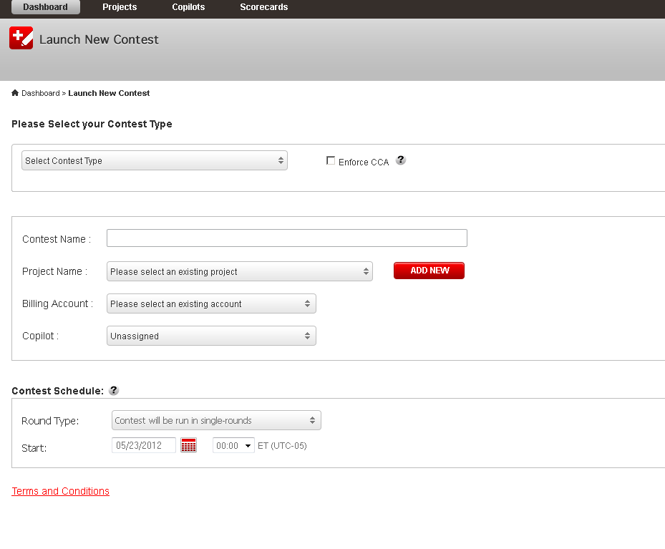
Click the Add New button to add new projects, like

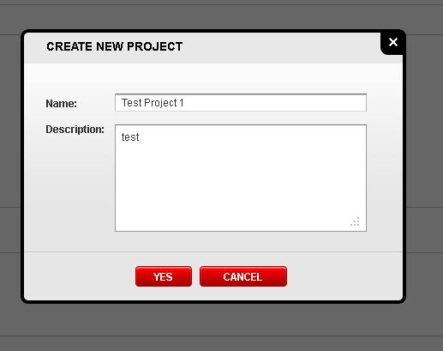

Create several new projects in this way, then create 1 – 2 draft contests under project, so we can also test project/contest notifications.

For each project, create server draft contests for that project.

Go to the edit project page of the created project

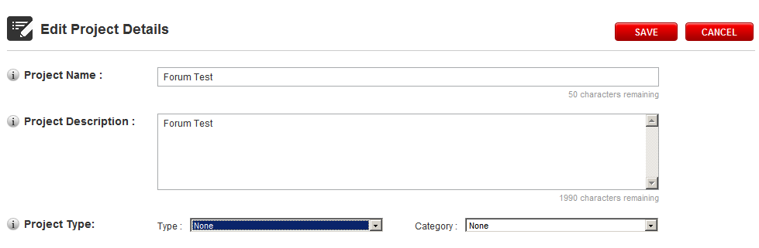

Choose the project type and category like

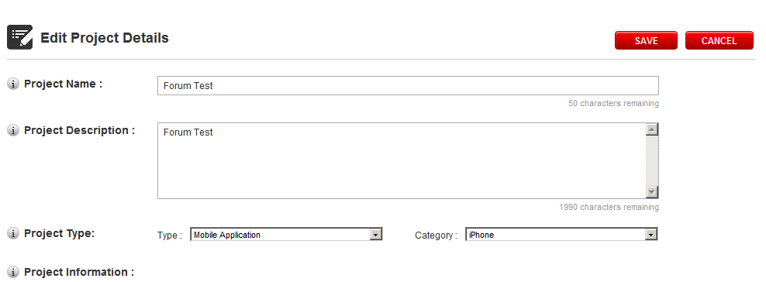

Click Save button, it goes to the project overview page

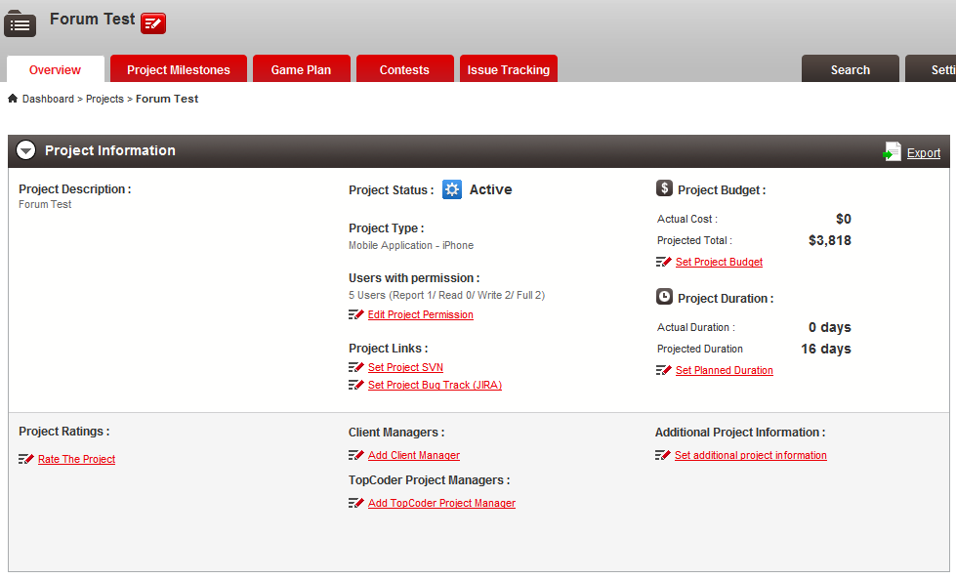

You can see the project type and category is displayed. The Users with permissions info is also displayed.

Click Edit Project Permission link, it goes back to edit project page with an anchor to the bottom section

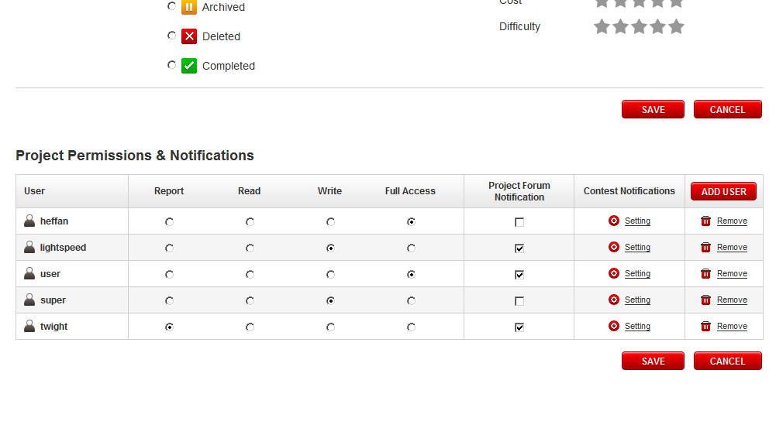

Click Add user to add the user like ‘Hung’

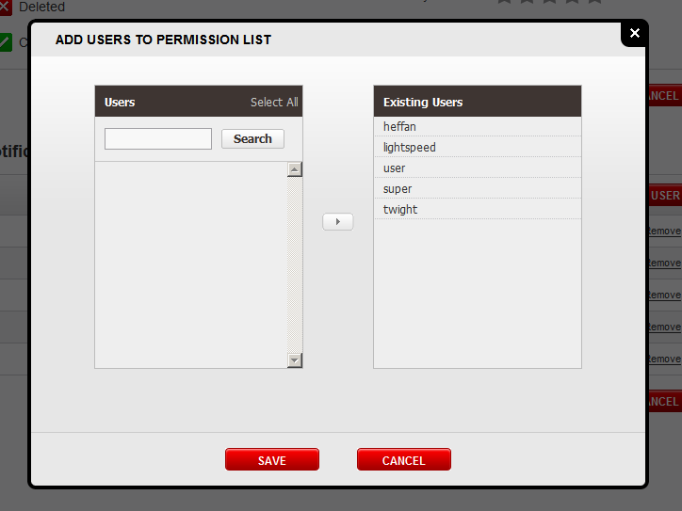

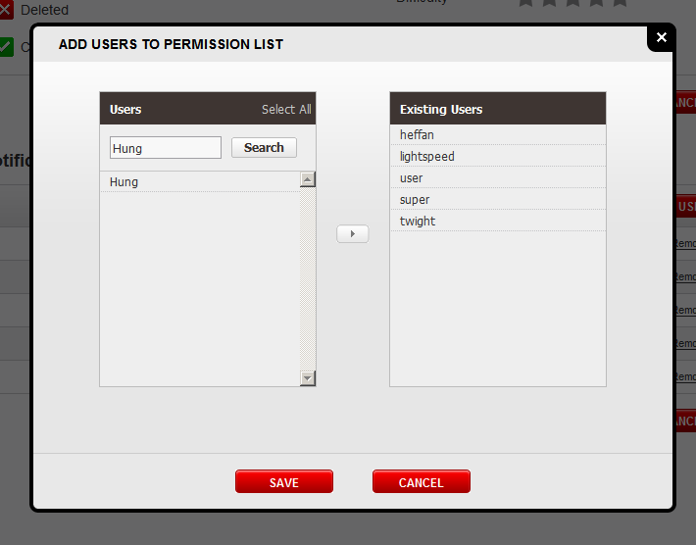

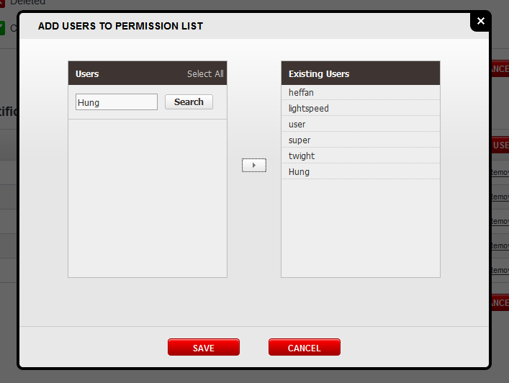

Modify the permission settings and click Save

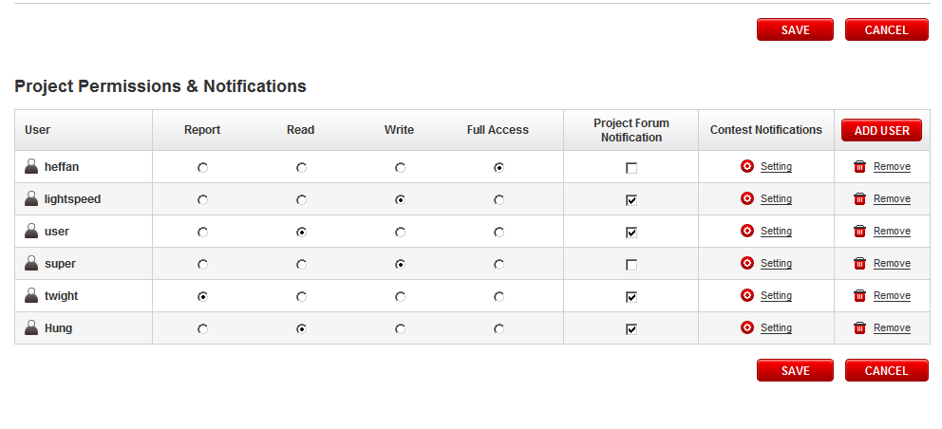

You will see

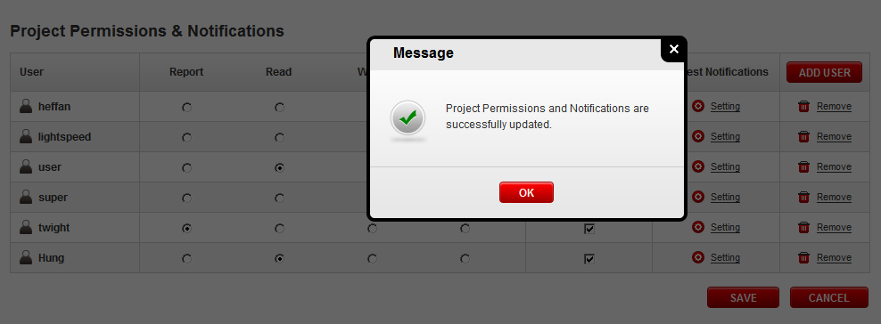

Click the Remove button to remove a user like Hung

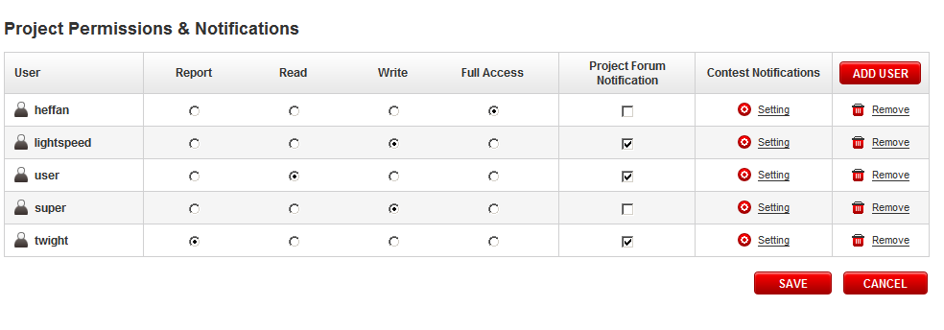
Click “Setting” button of an user like “Super”

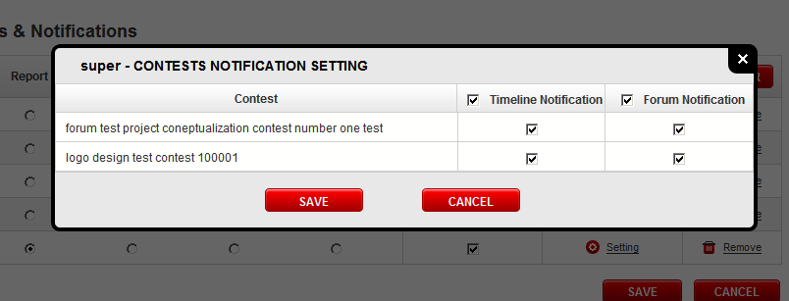

User should be able to set timeline notification and forum notification.

Apply some changes and click save

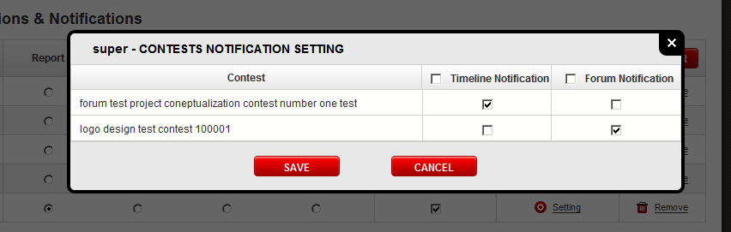

You should get response

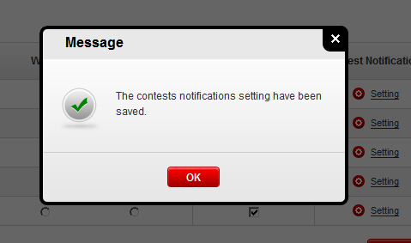

Verify 1.1.4

Input the 57000 into the budget, it shows

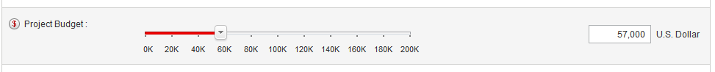

Move the slider, it steps in 1000

Resource Contact List

Name | Resource Email
TCSASSEMBLER

